1. wav; |w| = |v|; w,v patria do {a,b}*

{aaa, bab, abaab, baaba, aaaaa, bbabb,….}

b, A, BA

a, B, AB

b, B, BB



a, A, AA

b, Z, BZ a, B, epsilon

a, Z, AZ b, A, epsilon

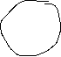

a,epsilon,epsilon epsilon, Z, Z

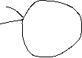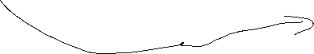

a, epsilon, epsilon

1. prevod G->PDA

G = (N,T,P,S)

P = {S -> aACA | A | b

A -> aABAS | aBB | bB | b

B -> +SC | bB | aAA | a

C -> + }

Riešenie:

PDA = {K, Σ, Г, δ, q_0, Z_0, F}

K = {q_0, q_1, q_r}

Σ = {a,b}

Г = {Z0, S, A, B, C}